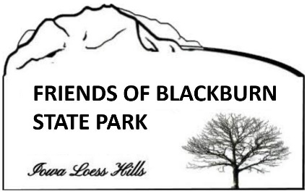
Donation Form
Friends of Blackburn State Park
Sent to:
Glenwood State Bank, Tabor Branch
711 Main Street
Tabor, IA 51653

From:

Name: ___________________________________________
Address: ___________________________________________
___________________________________________
___________________________________________
Email: ___________________________________________

Donation: Enclosed is my tax-deductible donation for deposit in the account of The Green Hollow Center, Inc., dba Friends of Blackburn State Park (Check appropriate box.):

- Check made payable to Friends of Blackburn State Park in the amount of $___________
- Cash in the amount of $__________

Total Donation: $_________

Comments: __________________________________________
_____________________________________________________
_____________________________________________________

Friends of Blackburn State Park contacts:
- Ken Forney, ph. 712.313.0315, email: reforney@hotmail.com
- Mike Younts, ph. 402.209.7292, email: myounts@fmtabor.org

Friends of Blackburn State Park (The Green Hollow Center, Inc.) is an Iowa nonprofit corporation, IRS Tax ID no. 26-463 9738, IA Secty of State corporation no. 378311.

