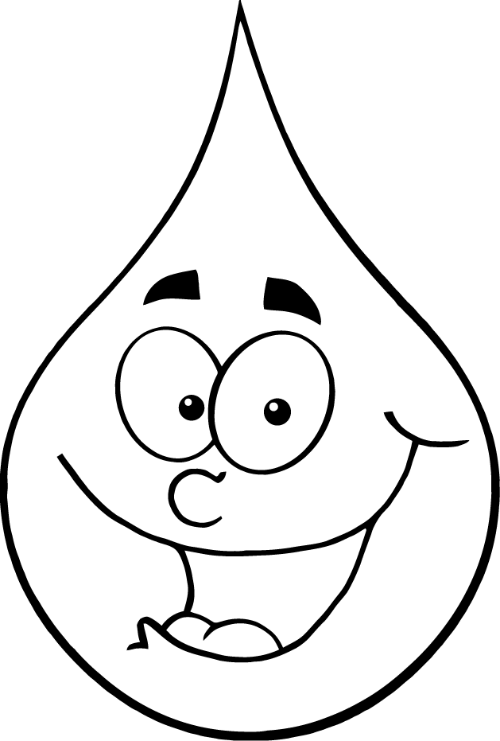
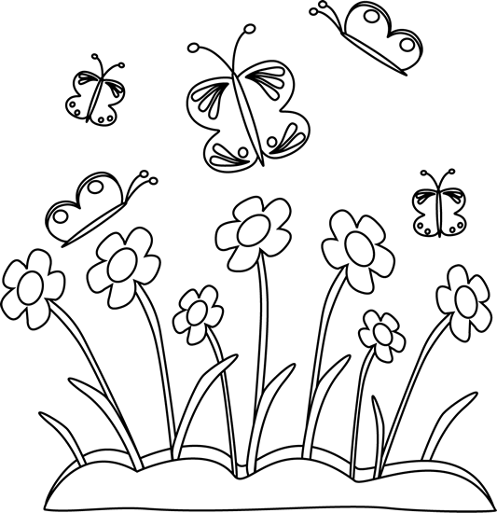
Explore Your Watershed Series presents:
Bringing Urban Practices to Rural Communities

A Youth Water Quality Saturday Day Camp with the opportunity to help build a Rain Garden at your local Fairgrounds!!

Saturday Day Camps
May 18, 9:00 to 12:00 Fremont County Extension Office
June 1, 9:00 to 12:00 Montgomery County Extension Office
June 1, 1:00 to 4:00 Avoca County Fairgrounds
June 8, 9:00 to 12:00 Mills County Extension Office

Rain Garden Builds:
June 10, 11, & 12 Mills County Fairgrounds
June 13 & 14 Montgomery County Fairgrounds
June 17 & 18 Fremont County Fairgrounds
June 19 & 20 E. Pottawattamie County Fairgrounds

The Saturday Day Camps are FREE but registration by Thursday prior to each is Required
Questions Contact Cara Morgan 712-249-6024 or Lance Brisbois 712-482-3029
For more information or to register online go to: http://www.goldenhillsrcd.org/wqi.html

------- Detach and Return to your County Extension Office by Thursday prior to the event---------

Name: __________________________________
Age: ____________________________________
Grade in School: __________________________
Circle one: 4-H FFA Other
Parent/Guardian: _________________________
e-mail: __________________________________
Phone: __________________________________
T-Shirt Size: ______________________________
Emergency Contact/Phone: ___________________________

Event Attending (select one):
- Fremont County: May 18, 9:00 to 12:00 Fremont County Extension Office

- Montgomery County: June 1, 9:00 to 12:00 Montgomery County Extension Office

- E. Pottawattamie County: June 1, 1:00 to 4:00 Avoca County Fairgrounds

- Mills County: June 8, 9:00 to 12:00 Mills County Extension Office

Parent/Guardian hereafter known as Releasor, wishes the Participant to participate in the WQI event coordinated by Golden Hills RC&D and participate in all activities except as noted on this form.
1. In consideration for the participation WQI event “Bringing Urban Practices to Rural Communities” Releasor hereby RELEASES and covenants not-to-sue Golden Hills RC&D for any and all present and future claims resulting from ordinary negligence on the part of Golden Hills RC&D property damage, personal injury or wrongful death arising as a result of engaging in, using the facilities and equipment, or receiving instruction for, or activities thereto, wherever, whenever or however the same may occur.
2. Releasor hereby voluntarily waives and all claims or actions resulting from ordinary negligence, both present and future, that may be made by Releasor's family, estate, personal representative, heirs or assigns. Further, Releasor realizes that participation in the WQI event “Bringing Urban Practices to Rural Communities” involves certain risks and danger and is a vigorous activity involving severe repertory and cardiovascular stress.
3. Releasor has hereby been made aware and acknowledges that participation in WQI event “Bringing Urban Practices to Rural Communities” has the following non-exclusive list of certain risks which I accept: death; head, eye, neck and spinal injury resulting in complete or partial paralysis; brain damage; heart attack; blisters; cuts; lacerations; abrasions; concussions; strains;sprains;dislocations; fractures; cold and heat injuries; water immersion; drowning; lightning strikes; injury to bones, joints, muscles,internal organs; and environmental conditions.
4. In addition, I understand and accept the incidental risks of travel to and from the site of activity; participation at sites that may be remote from available medical assistance; and the possible reckless conduct of other participants.
5. In the event of a medical emergency, Golden Hills RC&D or its representatives have my permission to take whatever measures they deem reasonable to render assistance and that I and/or my family will be financially responsible for any expense involved.
6. I have read and understand that this WAVIER is intended to be as broad and inclusive as permitted by the laws of the State of Iowa and agree that if any part is held invalid, the remaining parts of the WAIVER and RELEASE will continue in full force and effect as intended. I further agree that the venue for any legal proceedings shall be in the State of Iowa.

Signature: ___________________________________

Date: ____________________________________

