E&W Nishnabotna River WMC Quarterly Meeting
Wednesday Sep. 19, 2018
Oakland Community Center 9:00 am – 12:00 pm

Welcome & Introductions/Quorum Check
Sheryl Sanders

Agenda (Action)
East:
West:

Minutes of September Meeting (Action)
East:
West:
Update on Engineering Contract (Mills/Fremont)

Additional HUC 12’s
Approved for implementation
Iowa Soybean Assn. nominations

HMA Grant for top plan project (Action)

Iowa Flood Center –
Hydro Update, presented by Dan Gilles

University of Iowa CEA-
Survey Results, presented by Julie Kearney

IFC Flood Resiliency team
SVI Maps

Planning Update – JEO
- NRCS update on unbuilt PL566 structures
- ACPF map books, the results in an atlas format
- Review of the water quality
- Case study locations
- Updates on goals and objectives

Partner Updates (Discussion)
IEDA
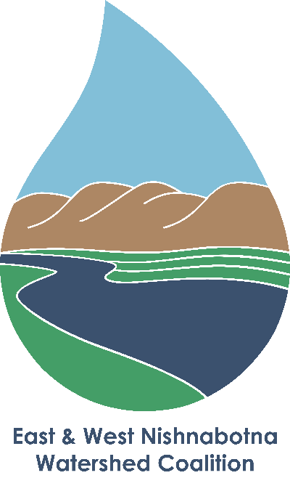
Grant Administrators
MAPA
SWIPCO
IDNR
IHSEMD
IFC
ISU
Extension
Water Center
Nutrient Research Center
Tall Grass Prairie

Upcoming Meetings (Discussion)
December 19 2018 Quarterly WMA Meeting

Closing remarks

Adjourn

