E&W Nishnabotna River Joint WMC Quarterly Meeting
Wednesday March. 20, 2019
Oakland Community Center 9:00 am – 12:00 pm

Welcome & Introductions/Quorum Check
Sheryl Sanders

Agenda (Action)
East:
West:

Minutes of December Meeting (Action)
East:
West:

Financial Report (Action)
East:
West:

SW Iowa Sourcewater Community Facilitator
Zachary Johannes

WQI Urban Water Quality Grant Update

Election of Officers (Action)

Instillation of 2019 East and West WMA Chairperson’s by 2018 Chairperson
Marion Durfey (East)
Mike Bargary (West)

Vice Chair
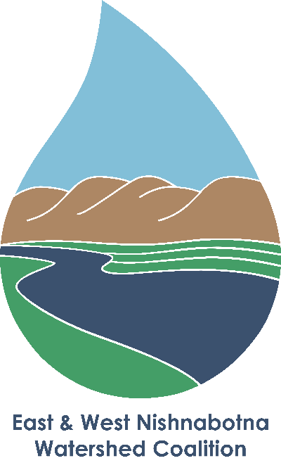
East:
West:

Secretary
East:
West:

Treasurer
East:
West:

Adjourn (Action)
East
West

Call meeting to Order with new officers (Action)
East:
West

JEO
Plan Update
Engineering Update

Partner Updates (Discussion)
IEDA
Grant Administrators
MAPA
SWIPCO
IDNR
IHSEMD
IFC
ISU
Extension
Water Center
Nutrient Research Center
Tall Grass Prairie

Resiliency Tournament

Upcoming Meetings (Discussion)
April 23 Watershed Plan Open House; Shenandoah
12:00pm to 2:00pm
5:00pm to 7:00pm
April 25 Watershed Open House; Harlan
5:00pm to 7:00pm
April 27 Explore Your Watershed Water Quality Float
June 19 Quarterly WMA Meeting
Sep. 18 Quarterly WMA Meeting

Closing remarks

Adjourn

